- SharePoint site URL and library path
- Client ID and Client Secret from Azure AD (for app registration)
- Tenant ID
- Proper permissions on SharePoint (usually delegated or application permissions for reading files)

Register an App in Azure AD (to get Client ID, Client Secret, Tenant ID)
Step 1: Go to Azure Portal
- Visit https://portal.azure.com
- Search for "App registrations"
- Click "New registration"
Step 2: Register the App
- Name: Something like DatabricksSharePointAccess
- Supported account types: "Accounts in this organizational directory only"
- Redirect URI: Leave it blank or put http://localhost (not used for this task)
Click Register
Step 3: Copy These Values
After registration, we’ll get:
- Application (client) ID
- Directory (tenant) ID
Step 4: Create a Client Secret
- Go to Certificates & secrets → New client secret
- Name it something like databricks-secret
- Set an expiry (e.g. 6 or 12 months)
- Copy the value immediately (this is your Client Secret)
⚠️ Note: You won't be able to see the secret again later
Give Permissions to Access SharePoint
Step 1: Go to API Permissions tab in the app
- Click + Add a permission
- Choose Microsoft Graph
- Choose Application permissions
Now add the following permissions:
- Sites.Read.All (to read all site contents)
- Files.Read.All (if you want to read all user files)
🛑 Important: These are application permissions (not delegated), so you must grant admin consent.

Step 2: Click Grant admin consent for [Tenant Name]
That’s it. Now your app has permission to access SharePoint content.

✅ Key Points:
- Microsoft Graph API requires Azure AD authentication (Client ID, Client Secret, and Tenant ID).
- You still need an Azure Active Directory account or service principal (App Registration) to authenticate and interact with SharePoint or OneDrive.

3. Do I Need Azure AD for All Microsoft 365 APIs?
Yes, for most API endpoints of Microsoft 365 (like OneDrive, SharePoint, Outlook, etc.), you will need Azure AD for authentication and authorization.
Short Summary:
- You do need Azure AD credentials (Client ID, Secret, Tenant ID) to access SharePoint or OneDrive via Microsoft Graph API.
- Even though you're using Databricks (standalone or not), authentication to Microsoft services still happens through Azure AD.

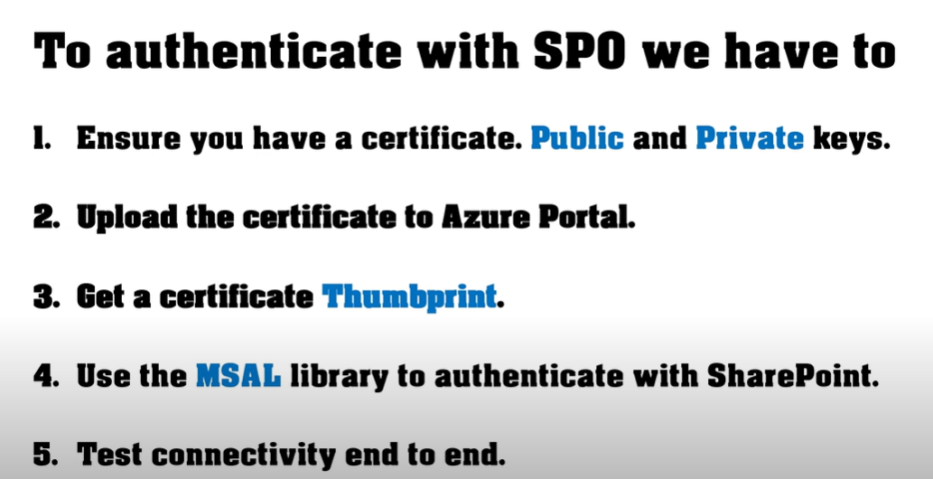

Another method:
What’s involved:
- Extract: Read metadata + SharePoint file URLs (likely from Excel or SharePoint List).
- Download: Get files from SharePoint.
- Transform: Format metadata to match Veeva Vault / Veeva CRM document object structure.
- Load: Upload documents to Veeva Vault using its API (REST or SOAP) with proper metadata.
Workflow:
Step 1: Read Metadata from Excel
Step 2: Download Files from SharePoint
⚠️ If your SharePoint requires authentication, you'll need to use Microsoft Graph API or Office365-REST-Python-Client with OAuth tokens.

Step 3: Format Data for Veeva
You’ll need to map your SharePoint metadata to Veeva’s document object structure. This might include:
- document_name
- product__c
- document_type__v
- version__v
- etc.

